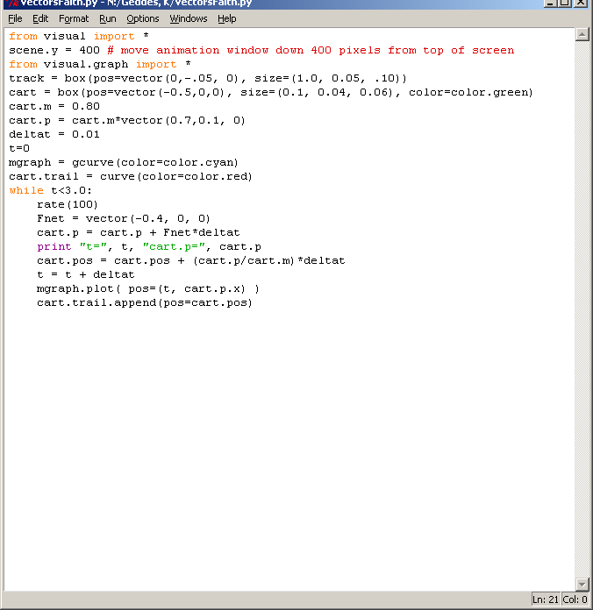
Sample Data:
t= 0 cart.p= <0.556, 0.08, 0>
t= 0.01 cart.p= <0.552, 0.08, 0>
t= 0.02 cart.p= <0.548, 0.08, 0>
t= 0.03 cart.p= <0.544, 0.08, 0>
t= 0.04 cart.p= <0.54, 0.08, 0>
t= 0.05 cart.p= <0.536, 0.08, 0>
t= 0.06 cart.p= <0.532, 0.08, 0>
t= 0.07 cart.p= <0.528, 0.08, 0>
t= 0.08 cart.p= <0.524, 0.08, 0>
t= 0.09 cart.p= <0.52, 0.08, 0>

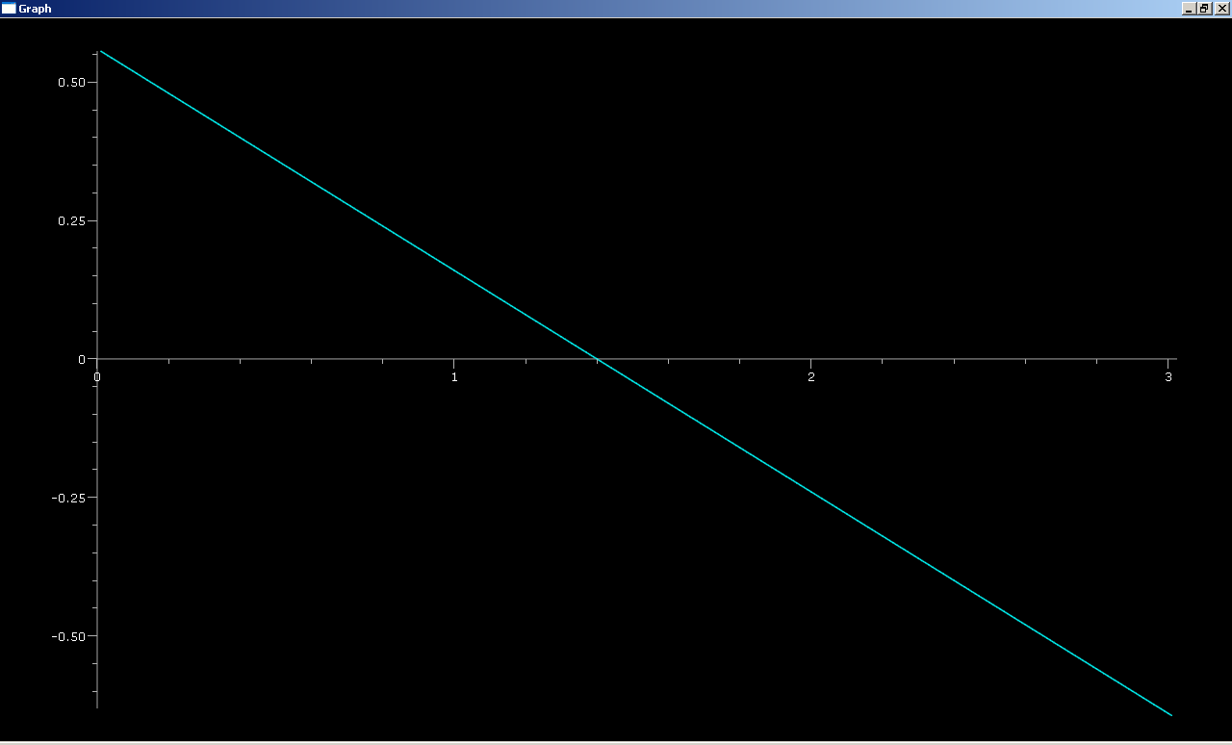

Questions:
1)
Initial p: t= 2.81 cart.p= <-0.568, 0.08, 0>
Final p: t= 2.82 cart.p= <-0.572, 0.08, 0>
Change in p=pf-pi=<-.004,0,0> kg m/s
2)
Pf= pi + Fnet*deltat
Fnet*deltat=<-.004,0,0> Nm
3) Yes. The two values are equal. Impulse is equal to change in momentum.
4)The cart is travelling on a horizontal surface, so the momentum, along with the velocity vector, only changes in the x direction.

